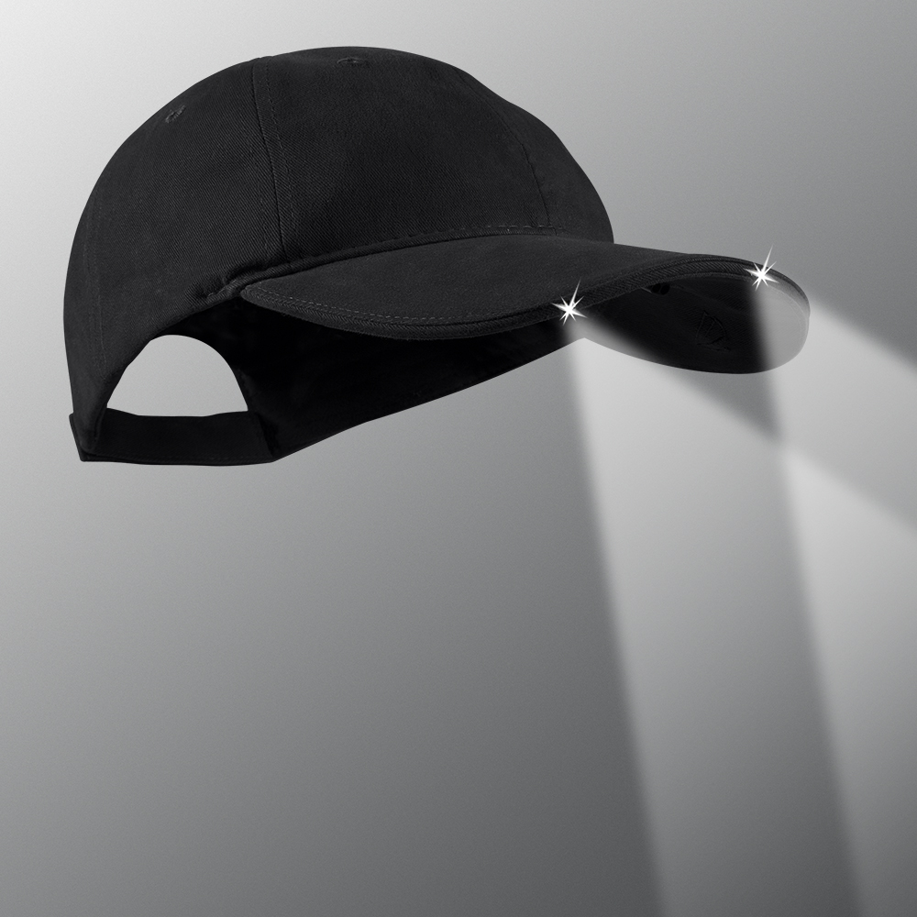
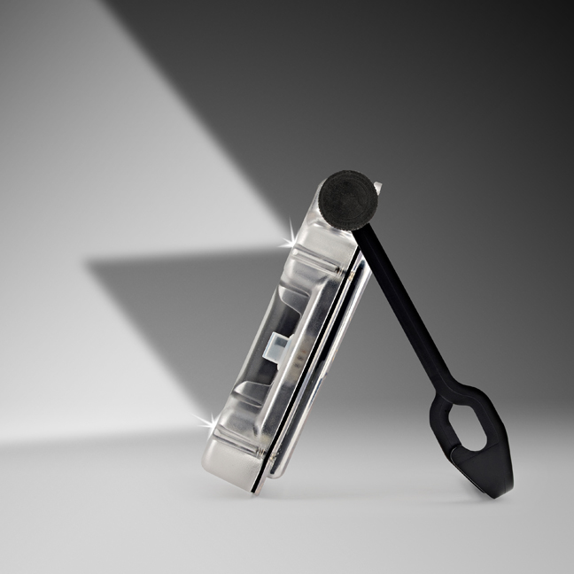
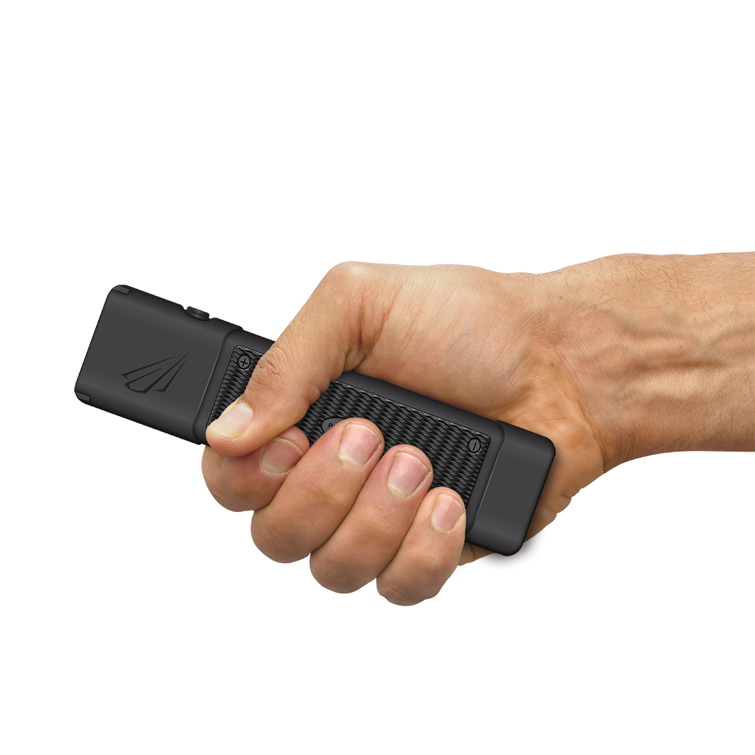
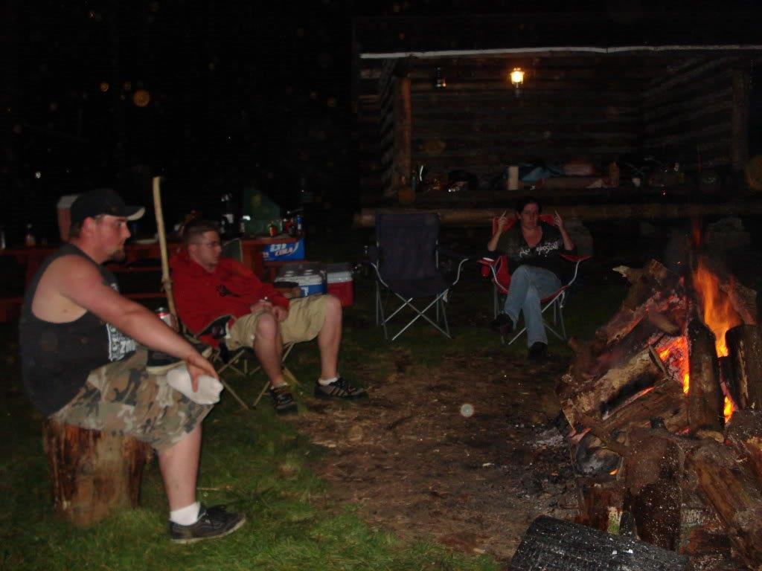
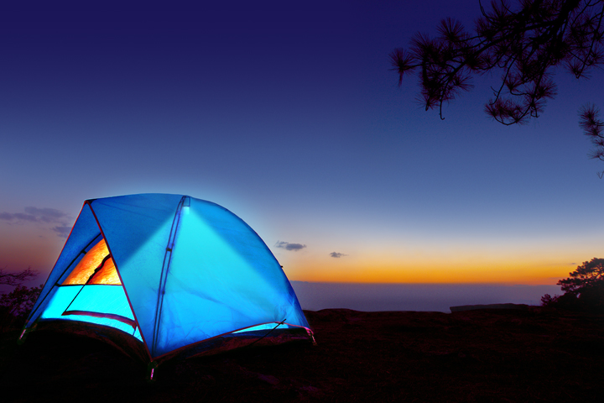

VISIT OUR WEBSITE WWW.PANTHERVISIONPROMO.COM
TO SEE THE FULL LINE OF LIGHTED PRODUCTS
OR CALL 847.783.5900 x 116 FOR MORE INFORMATION

VISIT OUR WEBSITE WWW.PANTHERVISIONPROMO.COM
TO SEE THE FULL LINE OF LIGHTED PRODUCTS
OR CALL 847.783.5900 x 116 FOR MORE INFORMATION

VISIT OUR WEBSITE WWW.PANTHERVISIONPROMO.COM
TO SEE THE FULL LINE OF LIGHTED PRODUCTS
OR CALL 847.783.5900 x 116 FOR MORE INFORMATION

FLATEYE THE UNROUND FLASHLIGHT
ASI 75825 SAGE 68668 PPAI 318255

VISIT OUR WEBSITE WWW.PANTHERVISIONPROMO.COM
TO SEE THE FULL LINE OF LIGHTED PRODUCTS
OR CALL 847.783.5900 x 116 FOR MORE INFORMATION

VISIT OUR WEBSITE WWW.PANTHERVISIONPROMO.COM
TO SEE THE FULL LINE OF LIGHTED PRODUCTS
OR CALL 847.783.5900 x 116 FOR MORE INFORMATION

LOVE CAMPING!!!
Bring your Panther Vision LED product along for your
Next GREAT adventures.

Consider a useful lighted hat, Solar Pac or FlatEye
for your next promotional customers

Easily add your customers’ logo
with embroidery , heat transfer or pad printing and give them a product that WORKS. Great for work or fun.

Grab them today and celebrate
summer camping

Add your logo here
CAPLIGHT 2000 SERIES
As low as $11.84 with 5,000 stitch logo (s)
SOLAR PAC
Blanks as low as $23.07 (s)
Blanks as low as $21.54 (s)

